Sawston Nursery would like to thank their suppliers:
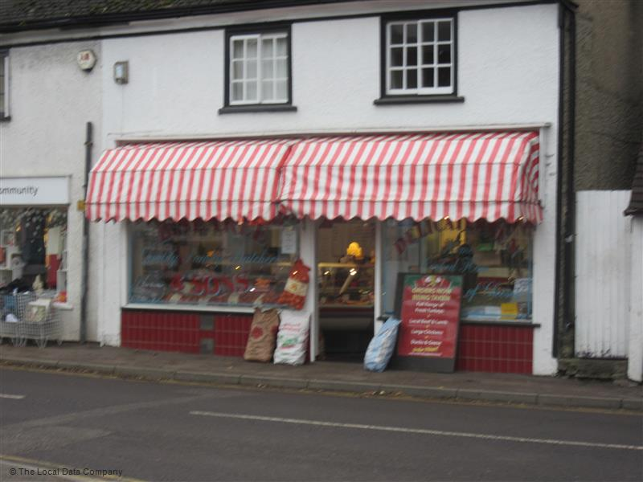
B Searle & Sons
Our local friendly butchers.
As all of our meals are freshly cooked each day.

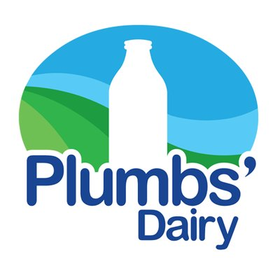

Plumbs Dairy
Our daily milk supplier.

Sainsburys Supermarket
Keeping our larder well stocked.

Along with other national companies Gomplells, Hopwells, Viking, ESPO and many more that help keep us running.
We also take our children to visit the Local Farm down Common Lane, the Spar, the Coop and Mary’s Greengrocer. We walk to these places when purchasing those little extra items to cook in the classroom, look for shapes, animals and items of food.
Thank you for all the local support.

Sawston Nursery

