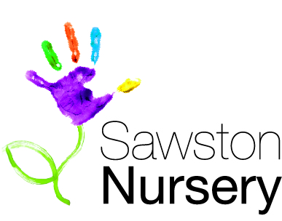
October 2017

Dear Parents. Grandparents and carers,

A month has passed and all of the children have settled in really well. They find their way around the room and follow the new routines brilliantly. At snack time in the morning the children find their own name label and fruit is provided whole rather than chopped. The children have lots of opportunity to learn new vocabulary which they enjoy using when we have visitors to the room. Lunchtime routines are going well with all children using a knife and fork and scraping their own plates after lunch, as well as stacking their own chairs (after checking which shape is on the back) that they have learnt to carry safely. The children lay the tables for tea and really enjoy pouring drinks for themselves. Putting on coats by themselves has proved very popular and most of the children have now got the hang of it. Independence is an area you can help to develop at home too! With mornings being very busy getting to work and school runs, it can be very difficult to allow independence with self help skills. Weekends are a great time to let the children show you what they can do for themselves. Helping to tidy toys, the responsibility of small tasks like laying the table for tea, putting shoes and coats on, can all support developing independence as well as listening skills.
The children have produced some fabulous paintings of themselves, and their friends and family members, in our “All about me” topic and have thoroughly enjoyed our harvest activities connected to the story of “The little Red Hen”, please pop in and have a look.
Our next topic will be “People who help us”! The children will be enjoying some great visits from the Dentist, a Fireman, and a Nurse. If you have an occupation of interest or that you would be willing to share information on please have a chat with staff in the room.

